School of _____________________________________
Department of ________________________________________________

Department Vision:

Department Mission:

Programme Educational Objectives (PEOs):

Programme Outcomes (POs):
PO | Statement
PO1: | Apply knowledge of Mathematics, Natural Science, Computing, Engineering fundamentals and an Engineering Specialization as specified in WK1 to WK4 respectively to develop to the solution of complex engineering problems.
PO2: | Identify, Formulate, Review research literature and analyze complex engineering problems reaching substantiated conclusions with consideration for sustainable development. (WK1 to WK4)
PO3: | Design creative solutions for complex engineering problems and design/develop systems/components/processes to meet identified needs with consideration for the public health and safety, whole-life cost, net zero carbon, culture, society and environment as required. (WK5)
PO4: | Conduct investigations of complex engineering problems using research-based knowledge including design of experiments, modelling, analysis & interpretation of data to provide valid conclusions. (WK8).
PO5: | Create, select and apply appropriate techniques, resources and modern engineering & IT tools, including prediction and modelling recognizing their limitations to solve complex engineering problems. (WK2 and WK6)
PO6: | Analyze and evaluate societal and environmental aspects while solving complex engineering problems for its impact on Sustainability with reference to economy, health, safety, legal framework, culture and environment. (WK1, WK5, and WK7).
PO7: | Apply ethical principles and commit to professional ethics, human values, diversity and inclusion; adhere to National & International laws. (WK9)
PO8: | Function effectively as an individual, and as a member or leader in diverse/multi-disciplinary teams.
PO9: | Communicate effectively and inclusively within the Engineering Community and society at large, such as being able to comprehend and write effective reports and design documentation, make effective presentations considering cultural, language, and learning differences
PO10: | Apply knowledge and understanding of engineering management principles and economic decision-making and apply these to one’s own work, as a member and leader in a team, and to manage projects and in multidisciplinary environments.
PO11: | Recognize the need for, and have the preparation and ability for i) Independent and life-long learning  ii) Adaptability to new and emerging technologies and  iii) Critical thinking in the broadest context of technological change. (WK8)

Knowledge and Attitude Profile (WK)
A Washington Accord program provides:
Knowledge and Attitude Profile (WK)
A Washington Accord program provides:
WK1: A systematic, theory-based understanding of the natural sciences applicable to the discipline and awareness of relevant social sciences
WK2: Conceptually-based mathematics, numerical analysis, data analysis, statistics and formal aspects of computer and information science to support detailed analysis and modelling applicable to the discipline
WK3: A systematic, theory-based formulation of engineering fundamentals required in the engineering discipline
WK4: Engineering specialist knowledge that provides theoretical frameworks and bodies of knowledge for the accepted practice areas in the engineering discipline; much is at the forefront of the discipline.
WK5: Knowledge, including efficient resource use, environmental impacts, whole-life cost, re-use of resources, net zero carbon, and similar concepts, that supports engineering design and operations in a practice area
WK6: Knowledge of engineering practice (technology) in the practice areas in the engineering discipline
WK7: Knowledge of the role of engineering in society and identified issues in engineering practice in the discipline, such as the professional responsibility of an engineer to public safety and sustainable development*
WK8: Engagement with selected knowledge in the current research literature of the discipline, awareness of the power of critical thinking and creative approaches to evaluate emerging issues
WK9: Ethics, inclusive behavior and conduct. Knowledge of professional ethics, responsibilities, and norms of engineering practice. Awareness of the need for diversity by reason of ethnicity, gender, age, physical ability etc. with mutual understanding and respect, and of inclusive attitudes
* Represented by the 17 UN Sustainable Development Goals (UN-SDG) : https://sdgs.un.org/goals

Sustainable Development Goals: 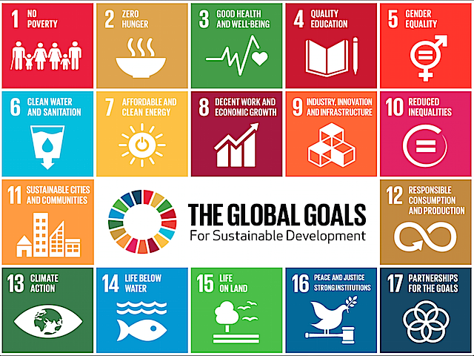

Programme Specific Outcomes (PSOs):

Head of Department
( Signature & Seal )

